
Pre-Semester Examination-2070
Full marks: 60
Pass marks: 24
Time: 3 hours.
SET A
Full marks: 80
Pass marks: 32
Time: 3 hours
Subject: TECHNICAL WRITING (ENG 256)

Attempt all the questions.
- Prepare a newspaper article in about 250 words making a comparison (contrast) between writing with and without computer. 10
- Read the following advertising and write a job application suitable and attach bio data with it. 15
Teacher wanted
Bernhardt College has a vacancy for a Teacher (Computer)
as a full time faculty.
Qualified candidate are suggested to appply
The principal
Bernhardt college, bafal kathmandu
Email: bernhardtcollege@gmail.com
- Write five acronyms in your area of study and their extended meaning. 5
- Write short notes on the following. 10×4= 40
- Graphic presentaion
- Aim and audience
- Writing in examinations
- The use of heading and numbering
- Describe briefly the layout of business letter. 10

Pre-Semester Examination-2070
Full marks: 60
Pass marks: 24
Time: 3 hours.
SET B
Subject: TECHNICAL WRITING (ENG 256)

Full marks: 80
Pass marks: 32
Time: 3 hours

Set B
Attempt all the questions.
- Prepare a newspaper article in about 250 words on ”the Use and Misuse of Mobile Phone” 10
- Write a sample cover letter to accompany you resume for a position in your field to the following person. 15
Mr. Ben Williams
Uni Tech International
GPO Box 11111
Kathmandu
- Describe the layout of memoranda. 5
- Write short notes of the following. 1×4= 40
- Minute
- Technical Writing
- Letter
- Business communication
- Describe the following graph. 10
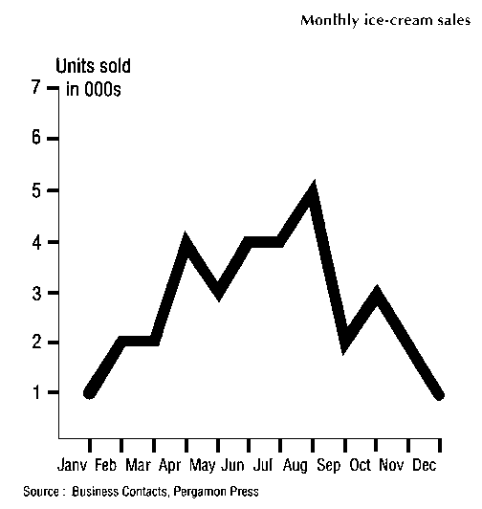
♦♦♦The End.♦ ♦♦

